**VV9:Create a Snapshot of a VM and Test it by loading the Previous Version/Cloned VM**

STEP1:

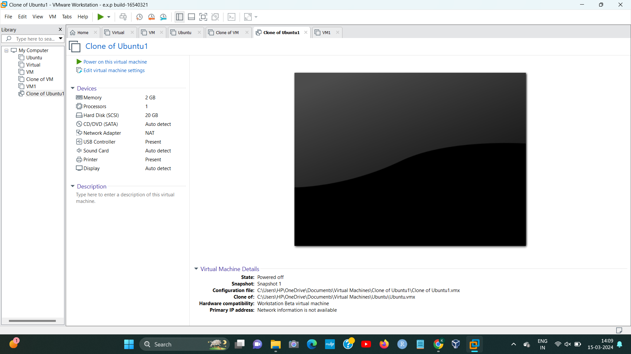

sTEP2:

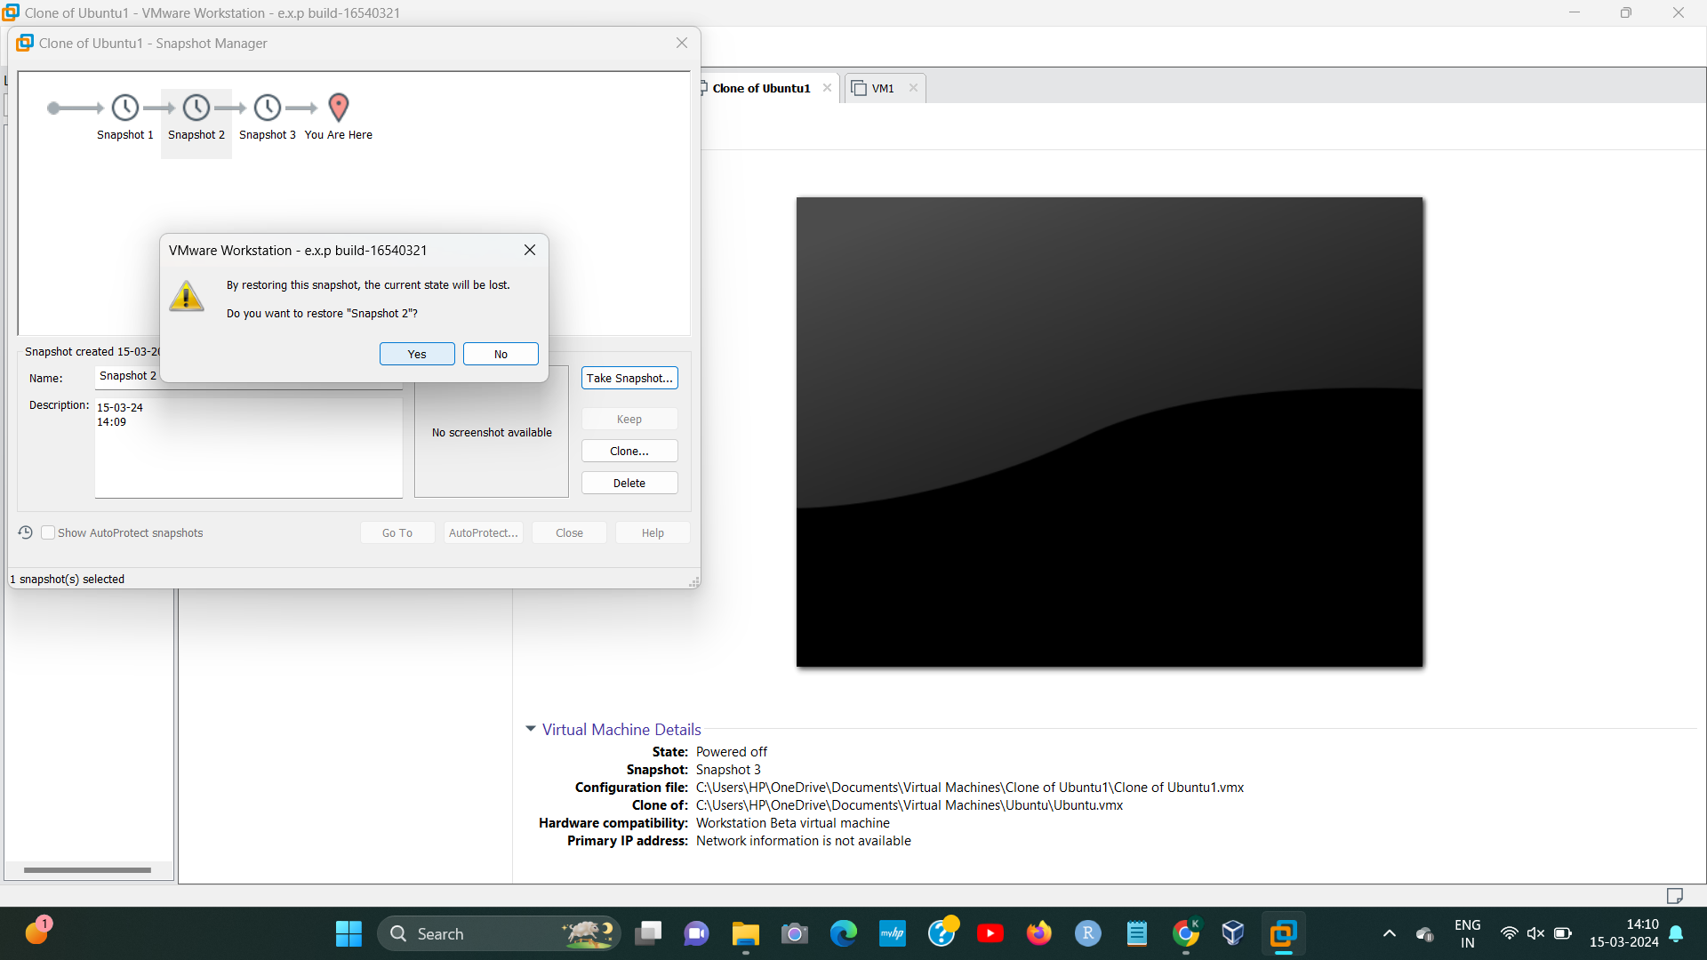

[1]

STEP3:

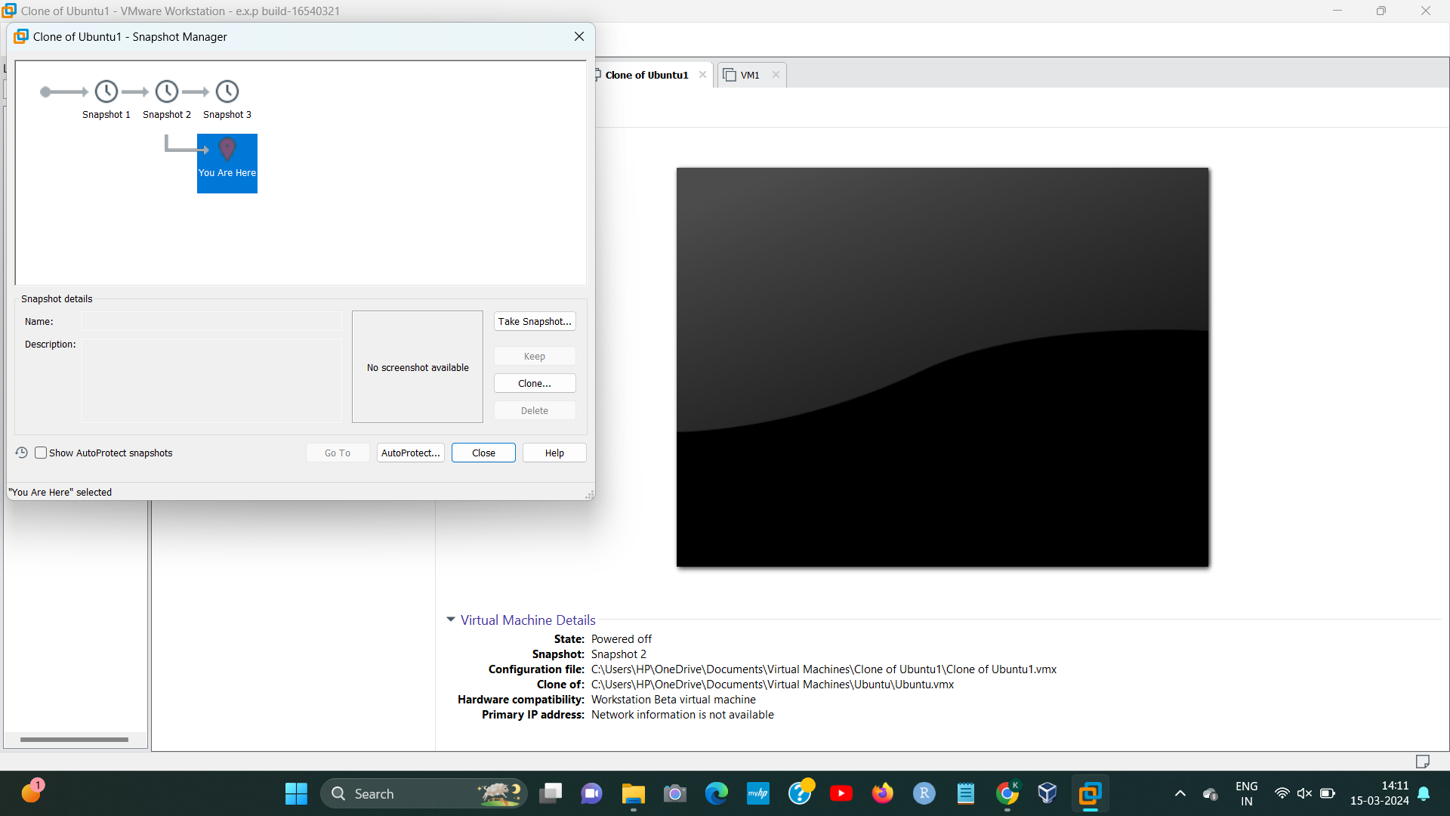

[2]

1. 192224191 L.KALYANI
2. 192224191 L.KALYANI